Preliminary Proposal for Global Adventure ‘Trek the Peaks of the Balkans Loop through the Accursed Mountains of Albania, Montenegro and Kosovo
June, July or September of 2027
The "Peaks of the Balkans" trek leads through one of the most remote and wild mountainous regions of the Western Balkans. On this 14-day adventure with 10 days of hiking and 2 days available for rest, we’ll hike a 75-mile part of a 119-mile cross-border trekking trail through the Accursed Mountains of Albania, Kosovo, and Montenegro, on shepherd paths and well-defined trails winding through high alpine mountains, reaching up to 7500 feet above sea level. Daily elevation gains and losses will range from 2000 to 4000 feet, with daily mileage ranging from 4 to 12 miles. On some days we’ll have a van transfer arranged to eliminate a long dull road walk. The terrain and trail conditions will range from well groomed paths and sections of country road to steep scree, but exposure will be modest – at most a steep drop to one or both sides from a narrow gravel path. See photos of typical terrain at this link. Participants will be carefully screened for recent experience and confidence trekking these distances, gains and terrain challenge levels.
The trip begins with flights into Podgorica airport, a van transfer to Shkoder Albania to meet our guide, then a transfer on to Theth Albania where our route begins (an optional pre-trip extension to explore the Montenegro coast will be offered). The route will pass into Kosovo and Montenegro and back into Albania – these borders used to be highly contested but now are easy to cross and the trail is well traveled. We will have a hired guide, van and driver (where needed), and each night we will stay in a mountain hut or village inn with basic amenities but including food, drink and a bunk or bed, so we only need to carry daypacks. Tap water isn’t potable in these areas so we will advise people to use bottled water and/or treat their own along the way. Environmental hazards are typical for high-mountain trekking in the summer – heat into the 80s some days, sometimes dropping to the 30s at night with potential for extended rain, and we’ll watch for lightning hazards on any long ridge sections (including skipping some trails if the hazard is high). There may be limited snow patches if we go in June (we are still deciding on optimal dates, as it can get hot in July through September) but they will mostly be melted and soft to cross. We will provide approved participants with detailed instructions and gear guidance before the trip to help them plan for the expected weather and trail conditions, and will review the next day’s weather and terrain the night before each trekking day to help everyone plan for the conditions.

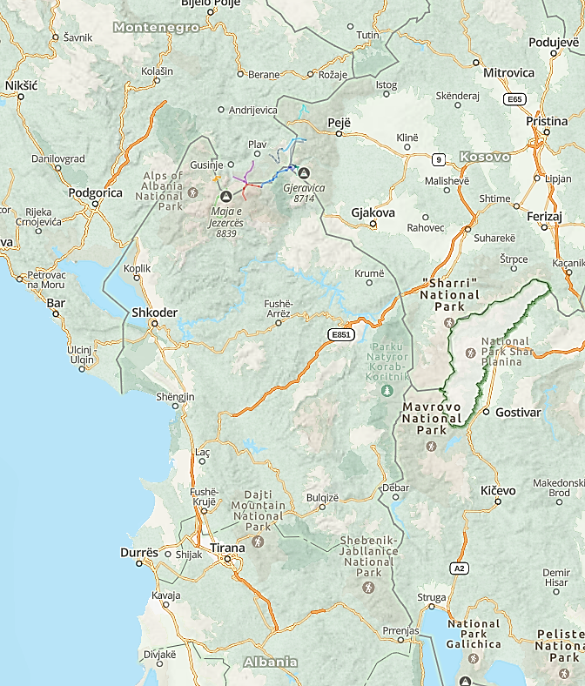
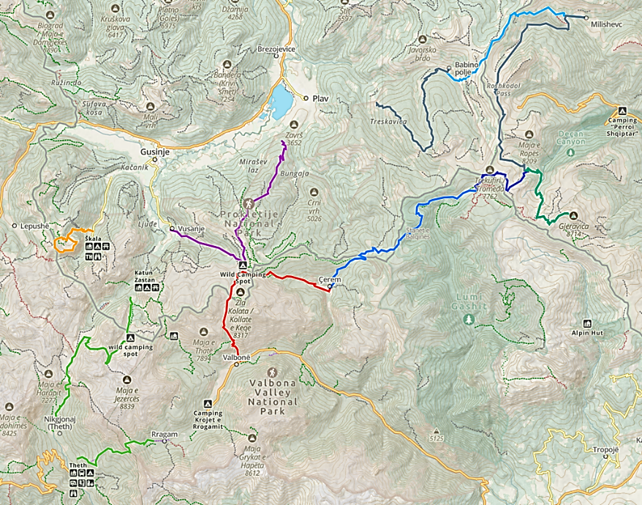
Sections skipped with a van transfer

